Php lecture #3

Squiggle line and it tells you that it’s redundant closing tag,which means tht if your file entirely contains php code meaning it’s 100 php then you do not need the closing tag and in fact we shouldn’t have the closing tag in those files and that is to make sure that no accidental white space or new lines are added after the php closing tag which could mess up your websites so.
If we inspect element here we only see the hello world and we don’t see any of the actual php code that’s because php
is a server side language.

Echo is what you would use to print something
we enclose the text within either a single or double quotes which indicates that it’s a string

exceptions where a semicolon is not needed for example fo you’re closing the php tag it will automatically assume
the semicolon on the last line before closing tag,

another way is the same thing as echo it just has couple of differences and I’ll mention those differences
now . Eg print has a return value of 1 which means that this expression right here actually returns
value an what I mean by that is that if I do echo and then print what this will do is that it will print out hello world and then append
one at the end because this expression itself returns one. This means that print could be used within expressions while echo can’t
<?php
print (‘hello world’); it will work
echo (‘hello world’);
if don’t use parentheses and you’re just echoing out text like echo ‘Hello’ , ‘ ‘ , ‘world’; and this
would basically concatenate all these three into one and print that to the screen . You cant do this with print.
echo 'ali\'s invoice'; it work
echo 'ali's invoice'; doesn’t work
echo "ali's invoice"; work also

variable start with $ sign $name = 'go';
echo $name;
rules when creating variables in php
must either start with a letter or an underscore
the letter can be either uppercase or lowercase but it cannot be a number or a special character eg
$1name = 'go';
echo $name; don’t work

$_123name = 'go';
echo $_123name; work

$this = ‘hello’; cant assing this to veriable because this refer to the objects.

$x = 1;
$y = &$x;

$x = 3;
echo $y;

1 will print but not 3 , that's because variables are assigned by a value. on the other hand if you actually wanted y to change whenver x changes then we need to assign variable by reference instead of by value. if assign reference by y then you need to add the ampersand & right here . Now answer 3.
so anytime $y = &$x; x change y will also change.

$firstName = 'go';
echo 'hello $firstName';
hello $firstName is result, and it’s not wht you would expect the first name here is just being printed
as is and that’s because we’re enclosing it within single quotes with single quotes with single quotes
the text gets printed as is meaning that you cannot use variables inside , if you want to get the value of the
variable then you need to change the single quotes to double quotes
$firstName = 'go';
echo "hello $firstName"; result hello go.
$firstName = 'go';
echo "hello {$firstName}"; it also work and plus claire.

$firstName = 'go';
echo 'hello ' . $firstName; dot here is concatenation operator.
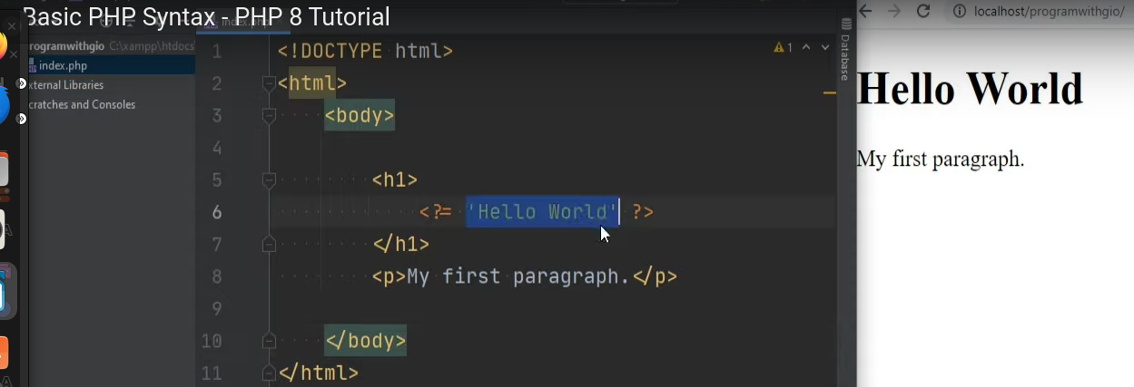

It also work If you print something but if you ned to process some php then you need to enclose your php code block within
the php opening and closing.

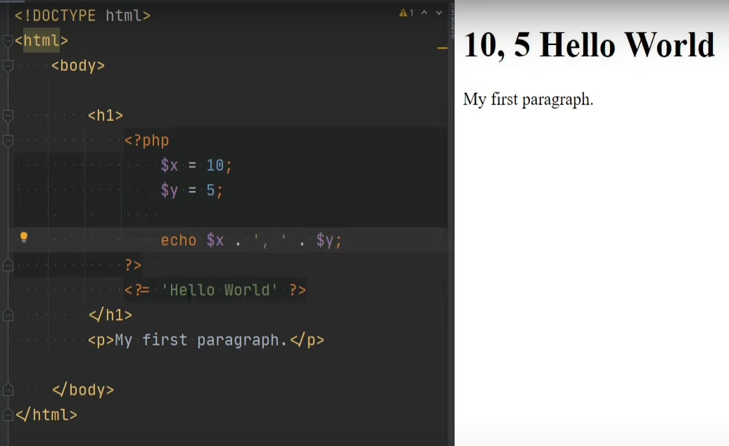

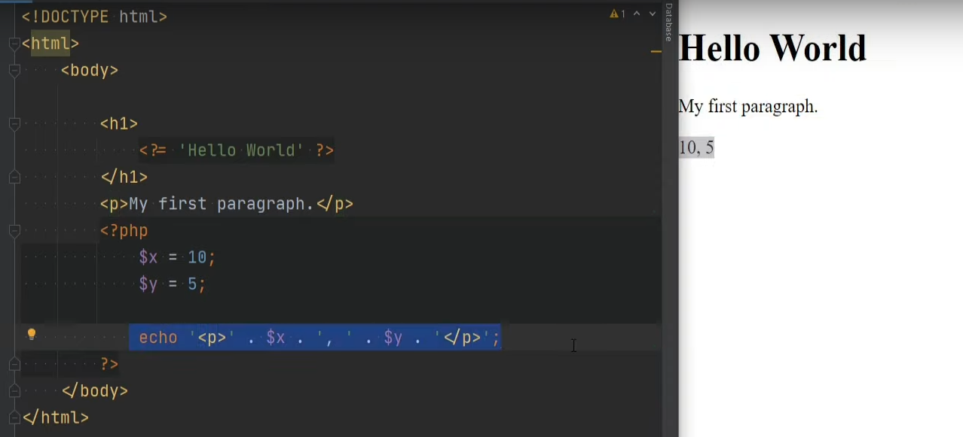

This can be useful for things like dynamically generated htmls for example but in general I would say that it’s not good idea to mix html
html directly in your php.

Php comment
//
#
/* multi line */
/**
*
*/ if you’ve seen something like this before this is something called duck blocks. Which you would use to write the documentation
for your source code.

